**AO8 Assignment- Data Analysis**

**Homeless Shelter**

**Group L**

***Introduction:***

If we solve the issue of homeless people not having access to shelters, with our solution to create a user friendly and accessible shelter that can be used by campers and homeless people, then we will be able reduce the amount of prejudice that homeless people face. In addition to the solution of the shelter we will also be following a one-for-one business model.

***Task:***

Homeless citizens living in inclimate weather.

***Problem definition:***

Seeking an affordable and efficient shelter that can withstand different weather conditions.

***Pains:***

1. Shelter is not typically portable and is difficult to move from location to location
2. Homeless people do not have enough income to afford permanent and effective shelter
3. Homeless people often have to settle for sleeping under bridges or in areas that are not very safe without any shelter to protect them
4. Homeless people are more prone to getting sick from exposure to the elements

***Gains***:

1. Homeless people gain more of a sense of privacy and personal space
2. Homeless people have the warmth they need to protect them from the cold
3. The ability to have a portable shelter and extra storage to protect their belongings from the general public

***Assessing User Experience of Homeless People in Finding/Using Shelter:***

| - - | - | 0 | + | ++ |  |
| --- | --- | --- | --- | --- | --- |
| X |  |  |  |  | Privacy |
|  | X |  |  |  | Storage of personal belongings |
| X |  |  |  |  | Comfort |
|  | X |  |  |  | Access to food |
|  | X |  |  |  | Ease of transportation |
|  | X |  |  |  | Ability to access shelter |
| X |  |  |  |  | Protection from sickness |
|  | X |  |  |  | Sense of community |
| X |  |  |  |  | Safety |
|  | X |  |  |  | Access to medical resources |

The chart above assesses the pains and gains that are associated with being homeless. This will allow us to understand how to better produce a quality product, to continue to maintain the gains and try to fix the pains. This chart informs us which aspects of homelessness most negatively affect the quality of life of a homeless person and therefore which most urgently need to be addressed. From this, we learned that our product should focus primarily on these four aspects of homeless life: privacy, comfort, protection from sickness, and safety. Though there are many negative aspects of being homeless, this chart helps us hone in on which specific aspects our product should improve.

***Persona:***

Our user persona is a fictitious representation of someone who will use our product. Creating a persona helps us better identify the primary user base for our product and shapes our marketing strategies. To create our persona, our group discussed what population we felt our product was mainly geared towards. We then considered numerous characteristics of our user base such as age, marital status, lifestyle, and hobbies and created our user persona accordingly.

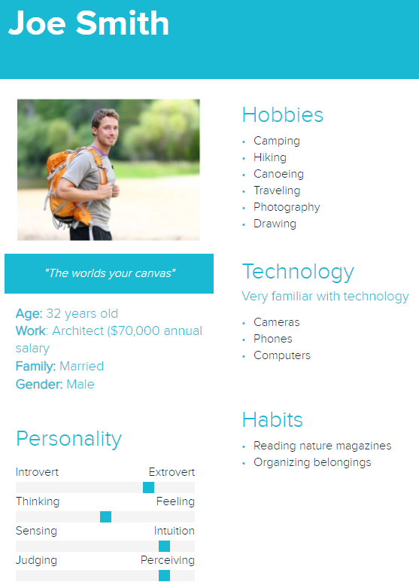

***User Needs:***

In order to best understand the needs of the potential users of our product, we created a chart outlining what we believed to be some of the most critical aspects of our design. Then, we rated each category by how important it was to include in our product given the needs of our users. Our team concluded that the most important features to include were long-term reusability, portability and convenience because our intended users will be using our product night after night, and have to carry it around during the day.

*1=least needed, 5=most needed

| User Need | Score (1-5) |
| --- | --- |
| Simple | 4 |
| Inexpensive | 3 |
| Portable | 5 |
| Long-term reusability | 5 |
| Comfortable | 3 |
| Convenient | 5 |
| Visually appealing | 3 |

Simple- The product needs to be simple enough to expand and compress quickly with ease and cannot be so complicated that it is difficult to understand and set up.

Inexpensive- Since we are planning on donating one shelter to a homeless person for every purchase, the product needs to be inexpensive enough to produce and sell while allowing for profit even with donating the shelters for free.

Portable- The product needs to compress enough to be portable and easy to carry around for people on the move.

Long-term reusability- The product needs to be of high enough quality to be reused and last long enough to shelter homeless people and campers for countless uses.

Comfortable- Though the product needs to compress and be portable, when expanded, the shelter provided needs to be comfortable to sleep and live in. In addition, the product must provide protection from the elements.

Convenient- The product needs to be easy to carry from place to place as well as set up and take down and must be able to be set up with any environment/location.

Visually Appealing- The product must be visually appealing enough to create a clean and beautiful city. While the product is first and foremost meant for shelter, it should also have an aesthetic element to it that beautifies cities and nature settings alike.

***Pairwise comparison Chart:***

The pairwise comparison chart helps us rank which features of our product we deem to be the most important. The chart also compares our initial rankings to our final rankings and weights them accordingly: the higher the total, the higher priority that aspect of our product is. For instance, we have decided that long-term reusability is the trait we value most in our product.

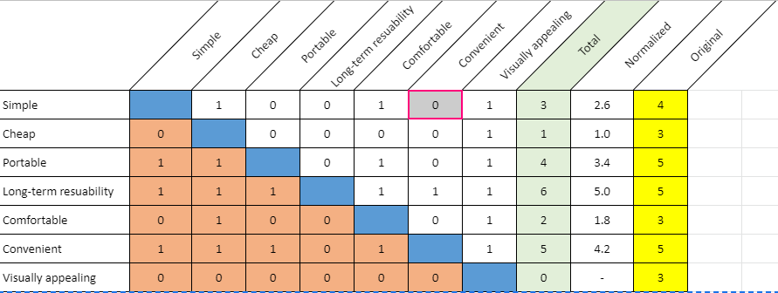

***Research Plan:***

1. **A description of the format of your primary research method (interview, focus groups, or survey)**
   1. For this project our group decided to use focus groups and interviews in addition to pre recorded interviews as our method of research. This was done to ensure that our group would get a large user base to gain information so that we can accurately judge the current market. This format also gives us the ability to gain accurate information on the market while making sure we don't trouble our user base.
      1. 1 focus group (2-3 people)
      2. 4 interviews
      3. Youtube videos interviews with guided outlines
      4. Pre recorded of a homeless shelter interview
      5. Interviews from Invisible People (<https://invisiblepeople.tv/> )
      6. Survey→ (To Identify data for campers)
2. **A plan to find and reach out to an appropriate number of users (8-10 interviews, 2-3 focus groups, or 25-40 survey results).**
3. Our group decided to first reach out to friends and family that fit the market we are trying to capture. Our market is primarily young to middle aged adults, an age range that is old enough to buy a tent but young enough to go camping frequently. If this user base does not provide a sufficient amount of users for our research, we decided to create a marketing campaign to inform the public about our focus groups and encourage users to sign up. The primary way we would achieve this is by creating flyers and asking local businesses and corporations to discuss our product with their employees and customers and encourage them to sign up. Finally, if we still need more interviewees, then our group has decided to lean on virtual resources like Youtube videos and other pre-recorded interviews so that this way we have the ability to reach an even wider user base that is not only in our local area but other states and countries as well.
   * 1. Friends and Family
     2. Marketing (Zoom Meeting)--> Ventech, Leah friends and parents (need confirmation)
     3. Youtube videos (with guided outlines), Pre-recorded interview, Invisible people
4. **Procedures for making our process as ethical as possible**

To make this process as ethical as possible our team first decided to make sure that, regarding our focus groups, we will not be visually recording them or collecting the individuals’ names. This ensures that every person's right to privacy is respected. However, in order to also ensure that our group gets the data we need from our market, the interviewees will be asked if they are comfortable enough to have their voice recorded this way the group will be able to review the data at a later time to make sure that all the data is accounted for. If all the participants of the focus group are comfortable with being voice recorded the participants need to give verbal confirmation and the interviewers will also discuss the destruction of the data once all the data has been received. Throughout this process interviewees have the option to leave the study at any time and their identity will be kept private through the duration of this project. Another thing that our group hopes to do in order to make sure that ethical practices are being followed is that each interviewer will make sure that they **DON’T** engage in confirmation bias. This means that when a response is given from the interviewee and it is not an answer we expected to get the group will write down and record only what the interviewee said and will **not change anything** from their response.

1. **Plan to Identify Additional Research:**

Because the goal of our design is to satisfy the needs of two different audiences, we need to make sure that our final product achieves the full capacity of its purpose. In order to do this, we need a thorough understanding of the needs of both campers and homeless people. Since the majority of our interviews will be with campers, we will need to do our own research about what the needs are of those who live on the streets. To do this, we will look for data about the circumstances of the homeless population, including any common medical issues that might make living on the streets especially difficult. We want to create our design with compassion in mind, so understanding these circumstances is a cornerstone to our project. In addition, we will explore several websites for homeless shelters to find testimonials from shelter staff or from shelter residents to gain further insight into a homeless person’s life.

We will also need to do research regarding the materials we will eventually use for prototyping and for assembling our final product. We want to optimize the quality of materials for their durability, providence of warmth, and aesthetic, while also ensuring that our product will turn out to be an appropriate price for the market.

Finally, if we decide to take this project past the design stage, we will want to do research on companies that could manufacture any parts for us that we are unable to create given our own facilities. To afford this, we would need to research and apply for grants that would help us to launch our product into the market.

The eight sources of outside research, condensed, are:

1. Data/statistics on homeless from government websites
2. Data/statistics on homeless from non-profit websites
3. Personal testimonials of homeless from non-profit websites
4. Data on trends for camping products on the market
5. Statistics on current tent competitors (which products are doing well right now?)
6. Information on different types of tent materials’ cost, durability, etc.
7. Research on potential part manufacturers
8. Research on eligibility for different types of grants
9. **The role of each team member**
10. We have decided that, while conducting research, the team will be split into two partner pairs. Each pair will be tasked with completing one focus group and two interviews. The partners will discuss and decide amongst themselves how they will split up the work and responsibilities for each task. For each task, the interview questions must be asked and notes taken on the responses. Someone will also be in charge of voice recording each meeting, but only after the users have consented to being recorded.
    1. 1 Focus Groups, whole team is responsible for 1

**6) Possible Interview Questions**

1. How often do you go camping?
2. What do you find to be the most difficult part of camping?
3. Do you prefer to camp alone or with others?
4. What type of weather do you typically camp in?
5. If you camp during cold weather, how do you typically stay warm at night?
6. On average, how many things does each individual person carry with them when camping? How many packs do these items require?
7. How would you describe your comfort level when sleeping in the shelter you currently use? What changes to that product would you make that would improve your camping experience?
8. Do you have any camping gear brands that you are loyal to? What do you like about those brands?
9. Do you typically prioritize quality or price when it comes to camping gear?
10. Having you noticed any recent trends in the camping industry?
11. How much would you be willing to pay for a product like this?
12. Do any other products/services come to mind when you think of this product?
13. What is your day job and what character traits do you think one must have to perform this job well?
14. What are the day-to-day tasks of your job?
15. How do you incorporate camping into your life? Do you see camping as an individual activity or a family-oriented activity?
16. If you knew that buying a certain camping product would contribute to providing shelter for the homeless, would you be more inclined to purchase that product?
17. Do you have any memorable experiences with the homeless population or serving in homeless shelters?

***Market Characteristics:***

1. **Stakeholders:**

Stakeholders are a person or group of people that are affected due to a common interest especially in business. As a result the people or group of people selected below are all affected in some way with the development of a homeless shelter.

* 1. Homeless people
  2. Campers (young/old people)
  3. Homeless Shelters
  4. People living in an area with a high homeless population
  5. The business around homeless people
  6. Other camping business (competitors)
  7. Camping grounds (nature reserves)
  8. City/Community leaders (mayors, governors)
  9. Producers and suppliers
  10. Distribution companies
  11. Shareholders (grant donors)

1. **Market Size:**

Defining the market size will give us an estimate of how many people are in our market and thus how many potential users/buyers there are locally, nationally, and globally.

* 1. Campers Market Size:
     1. When examining the camping tent market from the years 2020 to 2025 in the region of North America, Europe, Latin America, the Middle East, and Africa, it was identified that the current market revenue is valued approximately 3 billion dollars in 2025. That being said when factoring the **CAGR (Compound Annual Growth Rate) of 6%** and the **average price of a tent being $80** it can be identified that the population density of campers can be represented below with the graph. ([Camping Tent Market Size & Share | Global Industry Analysis Report, 2020-2025 (arizton.com)](https://www.arizton.com/market-reports/global-camping-tent-market-2025))

| Year | Market Size (Revenue) | The **left side** of the table includes the year and the market size in a monetary sense. While the **table on the right** includes the year and the Market size in terms of population which was achieved by taking the average price of one tent which was $80 and then dividing it by the market size (Revenue) to get the price of one tent which we assumed to be equivalent to one buyer of a tent or in other words a camper. | Year | Market Size (People) |
| --- | --- | --- | --- | --- |
| 2020 | 2,201,712,067 | 2020 | 27,521,401 |
| 2021 | 2,342,246,880 | 2021 | 29,278,086 |
| 2022 | 2,491,752,000 | 2022 | 31,146,900 |
| 2023 | 2,650,800,000 | 2023 | 33,135,000 |
| 2024 | 2,820,000,000 | 2024 | 35,250,000 |
| 2025 | 3,000,000,000 | 2025 | 37,500,000 |

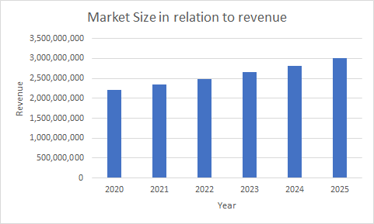

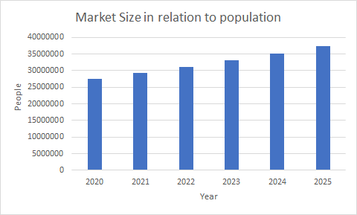

* 1. Homeless:
     1. In **2019, there were approximately 570,000 people** experiencing homelessness in the United States. This number is predicted to rise due to COVID-19 and will continue to rise as the economy and employment rates suffer and begin to recover. (<https://www.statista.com/statistics/555795/estimated-number-of-homeless-people-in-the-us/>)

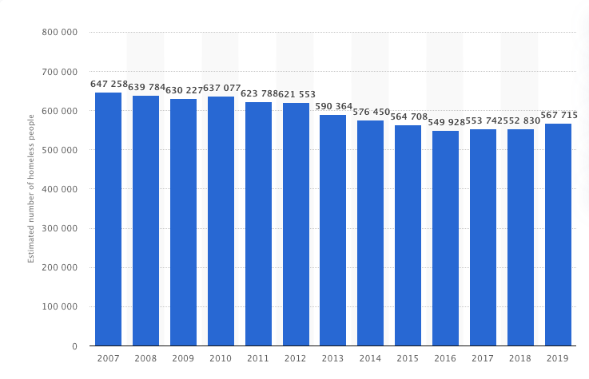

1. **Current Alternatives:**

Understanding current alternatives to our product that are already on the market is imperative to ensuring that our product satisfies our users’ needs to the best of its ability. By assessing alternatives in each category of user needs, we are able to better understand which user needs are overlooked and not accounted for, allowing us to make our product stand out among competitors in the market. From this high-level comparison matrix, our group learned that the majority of alternatives do not meet user needs when it comes to long-term reusability, comfort, and visual appeal.

| **User Need** | **\* Tents** | **\*\*\* Cabin** | **\*\* Blanket** | **\*\* Homeless Shelter** | **\*\* Under bridge** | **\*\* Nothing** |
| --- | --- | --- | --- | --- | --- | --- |
| **Simple** | **X** | **X** | **★** | **X** | **★** | **★** |
| **Inexpensive** | **X** | **X** | **★** | **★** | **★** | **★** |
| **Portable** | **★** | **X** | **★** | **X** | **★** | **★** |
| **Long-term reusability** | **★** | **★** | **X** | **X** | **X** | **X** |
| **Comfortable** | **★** | **★** | **X** | **★** | **X** | **X** |
| **Convenient** | **★** | **X** | **★** | **X** | **★** | **★** |
| **Visually Appealing** | **★** | **★** | **X** | **★** | **X** | **X** |

**Key:** * for both homeless and campers, ** for homeless, *** for campers

***Data Analysis:***

1. ***Secondary Research***
   1. **Source 1: Policy Advice**

*(This source was used in order to obtain data on homeless people (User Base) from reliable sources like the government)*

* Permanent housigintervantions have grown by 450% in 5 years
* The number of homeless in the US is estimated at 552,830
* Every year, 13,000 homeless people in the US die
* Homeless people have an average life expectancy of 50 years
* 20% of homeless individuals are kids
* Only 3% of affordable housing is available to people with extremely low income
* 70% of homeless people can receive temporary beds
* Over 65% of the homeless population in the US is in homeless shelters
  1. **Source 2: My Ope Country**

*(This Source was used in order to obtain data on our competitors, this data allowed us to see which companies currently dominate this space and how we can come in and separate ourselves from the rest of these people)*

* Top picks for tent brands are MSR, Big Agnes, Coleman, Kodiak Canvas, Jelty, R.E.I., The North Face
* Aluminum tent poles are stronger than carbon composite or fiberglass poles but are often more expensive and heavy. Rip-stop nylon fabric is cheap and will keep campers safe, warm, and dry and can endure shoes and harsh winds and rain.
* Material reinforcement on stress points and material that is at least four layers thick will be stronger against tears
* Removable rain flys with a mesh vents allows fresh air to enter the tent
* Roof-only styles are most susceptible to rain and moisture
* MSR: MSR products are made to last and withstand harsh environments and sell a variety of tents. MSR is known for withstanding freezing temperatures and summer. Quite expensive but good for backpacking and lightweight.
* Kodiak Canvas: hydra-shield canvas makes tents unique by providing breathability and air flow. Tents are not easily susceptible to rommon rips and tear and are made to last a lifetime.
* Coleman: known for rain flies that come with nearly every one of their tents. Tent line features a diverse price range for every customer budget. Known for making large family tents.
* Big Agnes: Tents are easily constructed for quick assembly. Many different styles to fit every individual need and provide an affordable price point.
* Kelty: credited with creating the first aluminum backpack. Seep backpacking and camping in mind. Fly vents keep out even the smallest gants.
* REI: donate millions of dollars each year to the environment, positive cause and durable gear. Known for making great tents at an affordable price.
* The North Face tents are great for cold weather. Designed for 1-4 people. Small but can withstand crazy temperatures while still having a good design.
  1. **Source 3: Big4 Holiday Parks**

*(This source was used in order to identify the most useful and durable material that can be used from our tents, because something that we valued high on our User needs chart was making our product have a long-term reusability factor)*

* Cotton/Canvas: extra temperature regulation, keeps you cozy but has great ventilation when things get too warm, less prone to condensation. Customers have to “weather” the tent themself before taking it camping to prevent moisture from getting in. Cotton/canvas is one of the more durable and waterproof tent materials available.
* PVC-coated tents: polyvinyl chloride coating makes canvas tents waterproof but also makes tents more prone to condensation so it’s essential to have good ventilation.
* Polyester-cotton: Provide strength and durability. Does not have to be coated to be waterproof but most have an additional waterproof layer. More affordable compared to other tent fabrics and will last many years.
* Polyester: More durable than nylon and available in a variety of coatings. The type of coating will affect the price. Tents need a coating with enough ventilation but does not let moisture in. Does not shrink or get heavier after coming into contact with water. Less affected by sunlight so good for summer.
* Nylon: Light material that ensures weight will stay to an absolute minimum. Among the most affordable tents on the market. Nylon fibres do not absorb water so an additional coating is not necessary, which also makes it lighter when wet. Some companies add a silicone, polyurethane, or acrylic coating. A coating should focus on durability. Silicone coating offers best overall protection but acrylic coatings are better for cost. Use ripstop weave in fabric to make it extra strong and durable.
  1. **Source 4: National Parks Service**

*(This source helped identify how many campers were camping under the national parks service. This was done in order to generalize the population of the data, it was decided that identifying all these campers will be a big enough sample size to obtain accurate data off of.)*

* In 2019 the amount of recreation visits happening within the National Parks Service was 327,516,619 people.
* In 2019 out of the 327,516,619 people visiting the national parks 13,860,047 stayed overnight within the national parks and this includes both recreational and non-recreational.
* In 2019 3 parks had more than 10 million recreation visits. These parks were Golden Gate National Recreation Area, Blue Ridge Parkway, and Great Smoky Mountains National Park.
* In 2019 11 parks had more than five million recreation visits, 80 parks had more than one million recreation visits, and finally 25 national parks had more than 1 million recreation visits.
* In 2019 the top 5 most visited parks were Golden Gate National Recreation Area which was at 15 million people, next was Blue Ridge Parkway at 14.9 million people, Great Smoky mountains National Park at 12.5 million people, Gateway National Recreation Area at 9.4 million people, and then finally Lincoln Memorial at 7.8 million.
* Over the last 5 years the total recreational visits for all national parks was 327,516,619 people in 2019, 318,211,833 in 2018, 330,882,751 in 2017, 330,971,689 in 2016, 307,247,252 in 2015 and finally in 2014 it was 292,800,082 people.
  1. **Source 5: Information About Being A Certified B Corporation**

*(This source was used in order to identify the direction of the project and where it should be going towards the end)*

* Certified B corporations envision a global economy that uses business as a force for good, and is a corporation that is purpose-driven and creates benefit for all stakeholders, not just shareholders.
* B Corporations Certification doesn’t just evalue a product or service; it assesses the overall positive impact of the company that stands behind it.
* B corps set the gold standard for good business and inspire a race to the top creating performance standards and legal structures being used by thousands of other businesses around the world.
* Any for profit company with at least a year of operations may pursue B corp certification. There is no minimum or maximum size, certain companies such as those under a year old, those with related entities, or large multinational and public companies, have additional consideration and requirements.
* B corp Certification is based in part on a companets verified performance on the B Impact Assessment which asks questions about a company’s fiscal year. This means that companies with less than one year of operation are not yet eligible for B corp Certification. Instead, they may pursue Pending B Corp Status, designed to set a startup on the right path to full certification.
* Certifying as a B Corporation goes beyond product or service level certification. B Corp Certification is the only certification that measures a company's entire social and environmental performance.
* Positive impact is supported by transparency and accountability requirements. B Corp Certification doesn't just prove where your company excels, it now commits you to consider stakeholder impact for the long term by building it into your company’s legal structure.
  1. **Source 6: Interesting Engineering**

*(This source was used in order to gather data on new technology in the camping sector and in order to identify the current market we are working with)*

* Shift in sales from traditional equipment like pole tents and rope to modern equipment like backpacking tents, accessories, stoves, and coolers
* Three big trends: camping equipment design, eco-friendly equipment, camping programs
* Equipment design: high-tech equipment to camp and stay connected such as ultra-compatible equipment, stoves that charge your phone, water-repellent sleeping bags, and bear-proof coolers. The biggest tech trend is hydrophobic materials that repel water and can be applied to everything like sleeping bags and other textile gear.
* Eco-friendly equipment: Manufacturers are starting to introduce “green” tents that are made from recycled materials treated with waterproof coatings that are free from harmful chemicals.Green materials generally cost more to manufacture so green products are sold at a premium and you may be able to charge 50% more for the end result.
* Camping programs: new wave of camping service providers that offer campsites as well as excursion and adventures under the guidance of professionals.
  1. **Source 7: Invisible People**

*(This source was chosen to get a better idea on what kind of people are homeless in America and how they live)*

Homelessness in America:

* Reasons: People become homeless for various reasons including economics, laws and public policy decisions, wars, natural disasters, societal trends, and public attitudes about who deserves support, not just not having enough wage to cover living expenses.
* Types of people homeless: Men and women, Families with children, Unaccompanied youth, Seniors, Veterans, Black and Native Americans.
* In more recent times, the number of homeless people has increased despite federal and other efforts to end homelessness for specific groups of people. Some people experience homelessness throughout their whole lives.
* Where they stay: Homeless people stay in emergency shelters, domestic violence shelters, and motels. They also live temporarily with friends and family and in cars, tent encampments, parks, campgrounds, and woods as well as under bridges and on streets and sidewalks.
* Physical and mental stress: Many homeless people have experienced domestic violence and other traumas. Homelessness also leads to increased feelings of uncertainty, vulnerability, and isolation. Many homeless people do not have access to medicine, regular physical or mental health care treatment, and education and job training opportunities.
* Possibility to help homeless people: Despite all this, it is possible to end homelessness. There are proven programs and policy solutions that support people in rebuilding their lives.
  1. **Source 8: United Way of the National Capital Area**

*(This source was used to identify the effect that covid-19 had on the homeless population)*

* Social services have become more limited throughout 2020
* Federal order to temporarily halt evictions to prevent the spread of COVID-19 which created a financial burden for landlord by housing renters with no payment
* In some states, households had to spend more than 50% of thor household income on housing payments (California, New York, Hawaii)
* Availability of health care has helped reduce spread of COVID-19 in homeless population with a prevalence of 9% on average
* From June to October, the COVID positivity rate for those experiencing homelessness wason average between 9% and 12%.
* COVID-19 has exacerbated many pre existing issues for those that are homeless
* Evictions due to COVID-19 left many people experiencing homelessneess and shelter were also forced to reduce occupancy at the same time

1. ***Primary Research:***

The Primary Research section includes recorded videos of real homeless people. These videos were watched by one member on the team and guided notes were taken through the duration of the video which can be found in the appendix. This was done in order to accurately understand our homeless population market like their wants and needs in a product, this was done so that during the design process we can accurately customize the product to fit their needs and wants.

**Invisible T.V. Interviews**

* 1. **Rita (Invisible people interview)**
     1. Rita was interviewed for the first time about six months prior to this most recent interview. The interviewer stayed in touch with Rita after their initial contact and decided to interview Rita again to see how the pandemic has changed her life as a homeless person. This interview was only conducted after Rita consented to being recorded on video. This interview was conducted in a manner closer to a casual conversation rather than an interrogation. The interviewer did not ask many specific questions but rather allowed Rita to talk about the things she felt were most important in her life right now. One specific question that was asked was “if you had three wishes, what would they be?” This question was asked to provide insight into what aspects of homeless life are most difficult for Rita and what she would change about her life or the society she lives in. After talking to Rita, our group is able to better understand the struggles she faced as a homeless woman in LA and what parts of being homeless frustrated her the most. One aspect of homeless life that frustrates Rita are programs that claim to care about the homeless community but provide quote on quote “support,” sometimes in the forms of lunches, only once and do not continue to help. Rita cares deeply about the environment and is even involved in a railroad beautification project called the Rainbow Forest Project. Rita also trims the palm tree and bushes near the railroad tracks to make it safer for homeless people living there. She also is highly involved in the community and even ran for neighborhood council to raise awareness about life as a homeless person and to support programs that support the homeless community. Rita is most frustrated by the lack of support for housing projects in LA and the interference of police in her life like the tickets and ambiguous instructions/threats from law enforcement to move during the lockdown. After interviewing Rita, the biggest takeaways are these: the wind, cold, and rats are the most harmful environmental conditions she experiences as a homeless person, personal hygiene is very difficult to maintain, homeless women are continuously abused and mistreated and are in need of safe refuge, and the general public should support affordable housing programs rather than the luxury housing projects typically found in LA. Rita’s three wishes are that she wished she had a pet unicorn, that she was not homeless, and that no one ever has to experience homeless ever again.
  2. **Simba (Invisible people interview)**
     1. Simba is a 65 year old homeless man who, after his wife died of diabetes complications four years ago, became severely depressed and started self medicating marijuana to help him sleep better. He was evicted from his home for smoking and has been homeless ever since. Simba was interviewed after he consented to being video recorded and asked questions. He also gave his street name in order to better protect his identity. Simba and the interviewer first met when a mutual friend was handing out cupcakes to the homeless people in the area. After meeting for the first time, the interviewer came back and interviewed him about his experiences as a homeless senior in Venice, LA. Simba was asked questions like “what was your first morning as a homeless person like,” “how are you surviving out here on the streets,” “what would you want people who judge you to know about homelessness,” and “if you could grant three wishes, what would they be?” Though these questions provided somes structure to the interview, the interviewer mainly just let Simba talk and tell his own story rather than asking him many specific questions. Simba expressed that the main way he survives on the streets is by dumpster diving, or “living off the land” as he calls it, reusing resources that people throw out every day. The biggest thing that has impacted Simba’s life as a homeless man are the motherly figures who watch over and care for the people in his community. He expressed his admiration and gratitude repeatedly for the people that watch over them and protect them when no one else will. For Simba, one of the most difficult things about being homeless are the health issues. As a senior, Simba struggles with incontinence and finds it extremely difficult to maintain his personal hygiene and privacy. Simba also describes how many homeless people do not even know the date or time of day. In addition to these struggles, Simba describes the most frustrating aspects of being homeless to be the lack of structure in his life, and being mistreated and judged by policemen and everyday people. Throughout the interview, cars were continuously driving past the spot where Simba lives, the noise being too loud to hear him talk as some onts in the interview. Simba's three wishes would be that everyone around the world appreciates their mothers, to not be seen as a target and mistreated by society, and that everyone becomes more thankful and works to spread love and not evil.
  3. **Mercy (Invisible people interview)**
* This interview was conducted in a manner closer to a casual conversation rather than an interrogation and not many questions were asked. Mercy had been homeless for 3 years on the streets of Los Angeles. When asked what happened to make him homeless, Mercy said “what didn’t, a little bit of that. A little bit of this.” Mercy kept mentioning how he used to judge homeless people before he himself became homeless and went on to talk about how a lot of homeless people are just ordinary citizens and that they became homeless because “stuff happens''. Mercy made safety seem like a major issue among the homeless. He explained to the interviewer how he got shot in his tent a year and a half before the interview. He also talked about how some homeless lady had her tent beams stolen and how he had to help her by giving her an extra tent. When asked what he likes to do, Mercy said he was a good cook and can cook anything. He would feed the homeless people on his street and cook for them. Mercy is very sympathetic towards other homeless people and says they are a community. When asked about what his 3 wishes would be, one wish he had was enough money so that he can at least get himself some basic necessities and live a life but also enough so that he could give back to other homeless people. When asked about future plans he replied with “I’m gonna get out of here” and said most homeless people have future plans on how to get out but struggle with their basic necessities. According to Mercy, “The streets have their own language. A person has to either adapt to the lifestyle or get killed. If you weren’t hard before South LA, the streets make you that way.“
  1. **Open Shelter Interview Summary**
     1. In the “Open Shelter” interview, there were two homeless interviewees who shared about their experiences being homeless. As explained by one of the interviewees, he fell into homelessness due to his lazy habits. He said that he didn’t care enough about managing his finances and that he used drugs. There was a period of cold days where he had to take refuge in a church, and he said he didn’t know how people who stayed outside those days made it. He said that he is currently trying to get back on his feet. He put a lot of emphasis on how he wishes there were more programs out there to help people like himself get education and jobs. He also said he wishes there were more places where he could wash his clothes, take showers, and get medical help. When it comes to shelter, he explained that he didn’t like how tents made him feel confined, so he usually chooses to sleep in a sleeping bag instead. He said that it was important to him that he had somewhere that he could stay warm and dry. Sometimes bugs were an issue for him, but racoons often attacked his tent and would steal food from him. He also had to worry about other people stealing his belongings. After explaining that, he said that the biggest concern was safety. He said that a lot of people have sleeping bags that keep them warm enough, but that the safety features could be greatly improved. A few other things he mentioned included how he kept personal identification papers in a ziplock bag in his backpack, how he sometimes used a grocery cart to transport his belongings, and how a good solution for a shelter would also mean that it is suitable to be carried with you on a city bus (in other words, nothing that is too big and bulky to be taken on the bus). After watching this video, we are taking the notion of safety, protection of belongings, and sanitation very seriously and we will be looking for ways to integrate these ideas into our current design to make it more user-friendly for homeless people and campers.
  2. **Focus Group with Bob (Alias) and Charlie (Alias)**
     1. In our first focus group interview, there were two participants: Bob (alias) and Charlie (alias). Both participants were asked a series of questions related to camping in all forms, and they were encouraged to answer based on their personal experiences and to build off of each other. Each participant explained all the questions in their own way; however, the top three questions that had the most common responses when examining the two participants involved Price, Design Features, and Marketing Tools. For starters, when examining the market size for campers, we found that the average price for a tent in the United States was $80. When discussing how much they would be willing to pay for a tent, they both agreed that a reasonable value would be between $100 and $200. Both participants felt the same way because not only would that price allow us to be a competitor in the current market but it would also justify our one-to-one model so that the company as a whole does not lose money.
     2. The next topic that participants agreed on involved the design features.The two participants felt very strongly that the tents should be able to protect a user against inclement weather, especially considering that the homeless are living outside continuously. One way our participants proposed we solve this is by incorporating either SmartWool or Emergency Blankets into the fabric of our tents so that the insulation and keep the user warm during cold and rainy weather. Another design concept that they suggested is the idea of an open concept to prevent feeling cramped. This issue was also expressed by a homeless person from our “Open Shelter Video”, where they had expressed that they tend to avoid shelters due to the feeling of being cramped. To combat this problem, the team decided to incorporate windows and an open concept within the entire tent so that not only will they have natural sunlight and a spacious feeling, but the window will also add a sense of security with the fact that they can see what is going on outside of their shelter.
     3. The final topic that we discussed was the idea of using the concept of “Hiking in the City” as a Marketing Tool. Hiking in the City is an event that one of our participants was part of with their church. The goal was to provide basic needs for homeless people. This was a great idea for us in the fact that it fits the entire brand that our company occupies. After conducting this interview, we are taking the notions of price, design, and marketing very seriously and we will be looking for ways to integrate these ideas into our current design to make it more user-friendly for homeless people and campers.

After performing this research, the team has collectively identified the most common characteristics desired amongst our prospective users in a potential design to include: lightness (portability), safety, storage of items, and comfort. The idea of the tent being lightweight was brought up not only in the Open Shelter interview, but also in the focus group with the campers. In the Open Shelter interview, the homeless people had expressed direct concerns of it being lightweight because, “the city transportation bus would not let them carry large items on to the bus”. This was also expressed by campers as they explained how having a shelter that is lightweight and portable is key to having a good camping experience. The less weight they must carry means the less they will be tried and the more they can explore. With these insights in mind, we brainstormed ways to meet this user need. The main way we came up with is to create the shelter with lightweight materials and to optimize the ratio between the space inside the tent and the amount of material used in weight.

The suggestion of safety was also expressed by both parties for similar kinds of reasons, because both of the markets had problems with their stuff getting stolen or them getting hurt whether that is a result of animals or humans. That being said in order to incorporate this insight we will be exploring options to add in windows so that the markets can see what's happening outside their shelter even when they are inside it.

The next concern that was expressed was the storage of items and other belongings. This topic was talked about by homeless people in the Open Shelter interview because they had referenced that when going into a homeless shelter you needed to provide documentation and many times when it rained they did not have any space to store those papers from getting wet and then losing it. Campers from our focus group also had a similar problem with this in the sense many times they are forced to take multiple bags for storage of gear because one bag doesn't provide enough space. As result, in order to combat this the team is looking to incorporate multiple places for storage along the backpack and maybe even a keychain that can be scanned to get into homeless shelters so we can eliminate the use of papers and the hassle of storing said papers.

The final concern expressed by our interviewees was about comfort. The campers explained how if there isn’t that much space inside the tent, you are more prone to rolling into the sides. The problem with this is that in the morning, there is often morning dew on the sides of the tent, so if you roll into the side, you will get wet, which will likely make you cold. In the interview with the homeless, comfort was emphasized as an important design aspect similarly to how the campers described. One of the homeless interviewees described how he did not like how sleeping inside tents made him feel confined. In order to address this issue in our design, we aim to make the dimensions of the tent compatible with the height of a person laying down (~6.5’ long), the height of a person in an upright sitting position (~4’ tall), and the span of an arm length (~3’ wide). Additionally, we talked about choosing colors for the inside of the tent that would give the tent a more spacious, airy feeling, such as shades of light gray, light blue, and white.

After our research analysis, the definition of our user needs have slightly changed and evolved to better fit the specific desires and frustrations expressed by users in our interviews and focus groups. After talking to current campers in our focus group and doing secondary research on market trends for camping gear, we have decided that our product being inexpensive is not a top priority. Our users have expressed that they are willing to pay for more for the various features offered by our product like our donation to a good cause, our use of environmentally friendly materials, and the portability of our product. Users described that they will pay 10-15% more for our product than for current competitors products, which changes our definition of inexpensive. Our definition of portable has not exactly changed, but has become more specific. Homeless users described the difficulties of fitting their personal items onto public transportation. Therefore, we now know that portable means it can be carried as well as easily fit onto public transportation and taken from place to place. Our definition of comfortable has become more broad after our research. Initially, when we thought of comfort, we thought of physical comfort. However, we now realize that emotional comfort is just as important to our users. For instance, one user expressed that tents can make them feel confined and unsafe. Comfort does include the agreeableness of the physical environment of our tent, but it also means that the user feels safe, secure, and their mind can be at ease in our product. In addition to the ease with which our product can be set up, our research analysis has also led to associating conviencince with the time it takes users to set up and take down our product. Some users described having to quickly pack up and move to a new location unexpectedly. Our product should not be time consuming to use to provide ample convenience for our users.

***Value Proposition:***

In Columbus alone, over 10,000 people live without knowing where they are going to sleep tonight. In all of the United States, that number increases to over 550,000. Maintaining a lifestyle of shelter insecurity is unsurmiseably difficult. People who find themselves homeless experience many challenges, including catching illnesses from being exposed to the elements night after night, feeling like they and their belongings are unsafe, and struggling to find ways to transport their many belongings in a way that is convenient and reliable. While completely solving the problem of homelessness may not be a feasible goal for a semester-long project, it is certainly possible to come up with a design that will help homeless people’s circumstances to become a little more manageable. Coming up with a design for a lightweight tent which can also be converted into a backpack has the potential to make a great impact on not only the homeless population in the United States, but also the camping industry. Our team will come up with a design that satisfies the needs of people experiencing homelessness as well as the needs of campers and backpackers, and if we followed a one-to-one business model (selling one tent to a camper and donating one to a homeless person), our market potential is incredible, allowing us to earn revenue from the more than 20 percent (Emmiemartin) of Americans who go camping year after year, and allowing us to provide shelter to the 550,000 Americans without homes. A successful product on our part could impact all fifty United States for the better.

After extensive research, our group has identified that the most valuable characteristics to include in our design are safety, portability, convenience, and long-term reusability. We decided these are the most important given what we learned in our research stage about the frequent struggles homeless people face. To ensure that our users feel safe and comfortable in their new shelter, we will incorporate a “window” feature to provide ample visibility of surrounding areas, and a locking mechanism to prevent break-ins so users can rest easy. In interviews, many of them described feeling as though themselves and their belongings are unprotected. Portability was an important characteristic because our homeless interviewees talked about either carrying many belongings themselves, or seeing others carrying many belongings. Creating a design that is portable is crucial so as not to add to the weight of the belongings they already carry. Our group is planning on incorporating portability into a potential solution by designing a shelter that can collapse into a backpack that can be easily carried on the move. We decided that convenience was also an important characteristic because we did not want our design to be difficult for our users to set up. Many of the homeless especially are hungry or tired, and the last thing they will want is to deal with something that is complicated and tedious to set up. We are hoping that our final design will be compressed in a way that allows the shelter to automatically expand upon opening with minimal manual setup required. The final most important characteristic we decided to include in our design is long-term reusability. If our users will be using our design daily and indefinitely, then it is critical for our design to last. To ensure this, we will use quality and durable materials with reinforcements along weak areas to prevent tearing. Incorporating all these characteristics will result in a quality product that serves the needs of our users.

***Works Cited***

*A material world. How to choose the best tent fabric for you | BIG4*. (2020). BIG4 Holiday Parks. <https://www.big4.com.au/tips-and-inspiration/tips-advice/camping/how-to-choose-the-best-tent-fabric#:%7E:text=Tents%20made%20completely%20from%20polyester,a%20specific%20polyester%20tent%2C%20though>.

A.A.&. Intelligence. (2020, February). *Camping Tent Market Size & Share | Global Industry Analysis Report, 2020-2025*. Arizton Advisory & Intelligence. <https://www.arizton.com/market-reports/global-camping-tent-market-2025>

Adavelli, M. (2021, January 31). *Homelessness statistics in the US for 2020 | Policy Advice*. PolicyAdvice. <https://policyadvice.net/insurance/insights/homelessness-statistics/#:%7E:text=On%20a%20single%20night%2C%20more,are%20living%20on%20the%20streets>

Certified B Corporation. (n.d.). *Certified B Corporation*. Retrieved February 4, 2021, from <https://bcorporation.net>

Conghalie, B. (2020, October 31). *Best Tent Brands (and Shelters) of 2021*. My Open Country. <https://www.myopencountry.com/best-tent-brands-shelters/>

Emmiemartin. (2018, August 09). 77 million Americans Go Camping-and 22 percent spent nothing to get started. Retrieved February 06, 2021, from <https://www.cnbc.com/2018/08/09/how-much-first-time-campers-pay.html>

English, T. (2019, October 4). *Hottest Trends in Camping: How Has Technology Changed the Industry?* Interesting Engineering. <https://interestingengineering.com/hottest-trends-in-camping-how-has-technology-changed-the-industry>

Fish, G. (2021, January 11). *The Impact of the COVID-19 Pandemic on Homelessness in the United States*. United Way NCA. <https://unitedwaynca.org/stories/effect-pandemic-homeless-us/>

Moses, J. (2020, May 22). *COVID-19 and the State of Homelessness*. National Alliance to End Homelessness. <https://endhomelessness.org/covid-19-and-the-state-of-homelessness/>

Homelessness Archives. Invisible People. Retrieved February 4, 2021, from <https://invisiblepeople.tv/category/learn-more/homelessness/>

Horvath, M. (2020, Dec. 2). Evicted After Wife Died, Now Homeless in Venice Beach. *Invisible People.* [https://invisiblepeople.tv/videos/elderly-homeless-man-venice- beach/](https://invisiblepeople.tv/videos/elderly-homeless-man-venice-)

Horvath, M. (2020, Dec. 30). UPDATE: Rita is still homeless in Chatsworth. *Invisible People*. [https://invisiblepeople.tv/videos/homeless-woman-chatsworth-los-ang eles/](https://invisiblepeople.tv/videos/homeless-woman-chatsworth-los-ang)

Horvath, M. (2021, Jan. 20). Homeless on the Cruel Streets of South Los Angeles. *Invisible People.* <https://invisiblepeople.tv/videos/homeless-south-los-angeles/>

Statista & US Department of Housing and Urban Development. (2007–2019, January 20). *Estimated number of homeless people in the U.S. 2007-2019* [Dataset]. US Department of Housing and Urban Development. <https://www.statista.com/statistics/555795/estimated-number-of-homeless-people-in-the-us/>

Jayakumar, A. (2021, Feb. 4). Open Shelter.

*Visitation Numbers (U.S. National Park Service)*. (2020, March 10). National Parks Service. <https://www.nps.gov/aboutus/visitation-numbers.htm>

***Appendix:***

| **AO8 Assignment** | | | |
| --- | --- | --- | --- |
| **Project Manager for Assignment** | | | |
| Ashwin Rajkumar | | | |
| **Deputy Manager for Assignment** | | | |
| Leah Norton | | | |
| **Drafted Assignment** | **Reviewed Assignment** | **Revised Assignment** | **Proofread Assignmnet** |
| Ashwin Rajkumar | Leah Norton | Ella Wulforst | Avi Popat |
| **Created Figures** | | **Created Tables** | |
| Ella Wulforst | | Leah Norton | |
| **Other Contributions** | | | |
| N/A | | | |
| **Problems Overcome** | | | |
| N/A | | | |

***Guided Notes from video Data***

***Open Shelter Data Ashwin:***

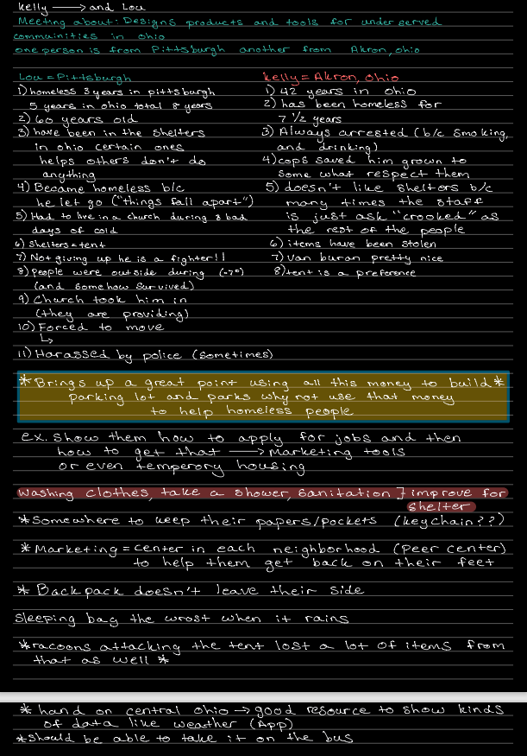

***Open Shelter Data Leah:***

Became homeless from laziness, drug use, poorly managed finances

Took shelter in a church

Trying to get back on feet

Don’t like tents because don’t like being confined, usually just sleep in sleeping bag

They need help with getting jobs, education

They need places to wash their clothes, take showers, get medical help

Children in need of food, clothing, medical supplies

Keep documents in backpack in a ziplock bag

Use Kroger carts to transport some belongings

Some have a lot of belongings, others just keep the things they really need

Need somewhere to keep dry

Weather resistant sleeping bags are the best kind of sleeping bags

Satisfied when you’re kept dry and warm

Sometimes bugs can be a problem but they aren’t the most pressing issue

Raccoons attack their tents and steal food from them

Have to worry about other people coming up and stealing your things

It would be good for the solution to be suitable for taking with you on the bus

The biggest concern is keeping stuff safe

A lot of people have warm sleeping bags, so the shelter doesn’t necessarily need to be super warm, focus slightly more on safety features

***Mercy Invisible TV interview Data Avi:***

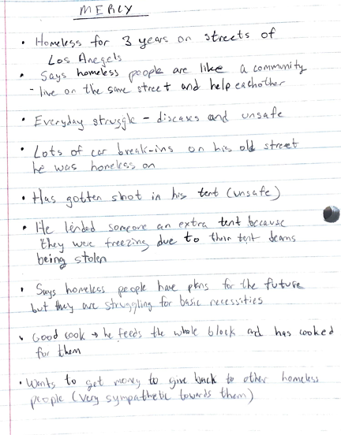

***Rita Invisible TV interview data Ella:***

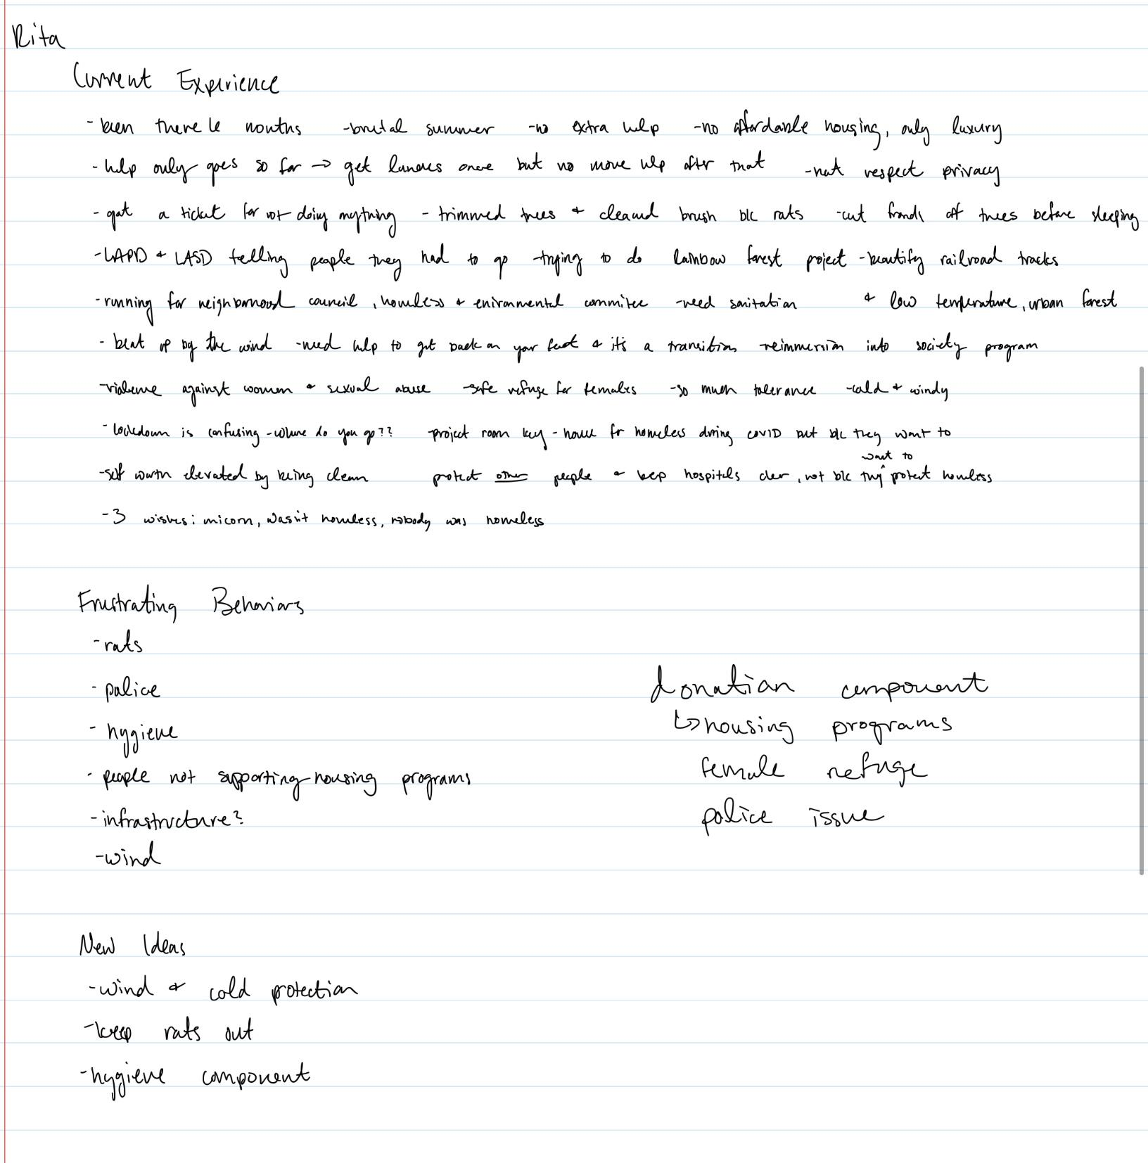

***Simba Invisible TV Interview Ella***:

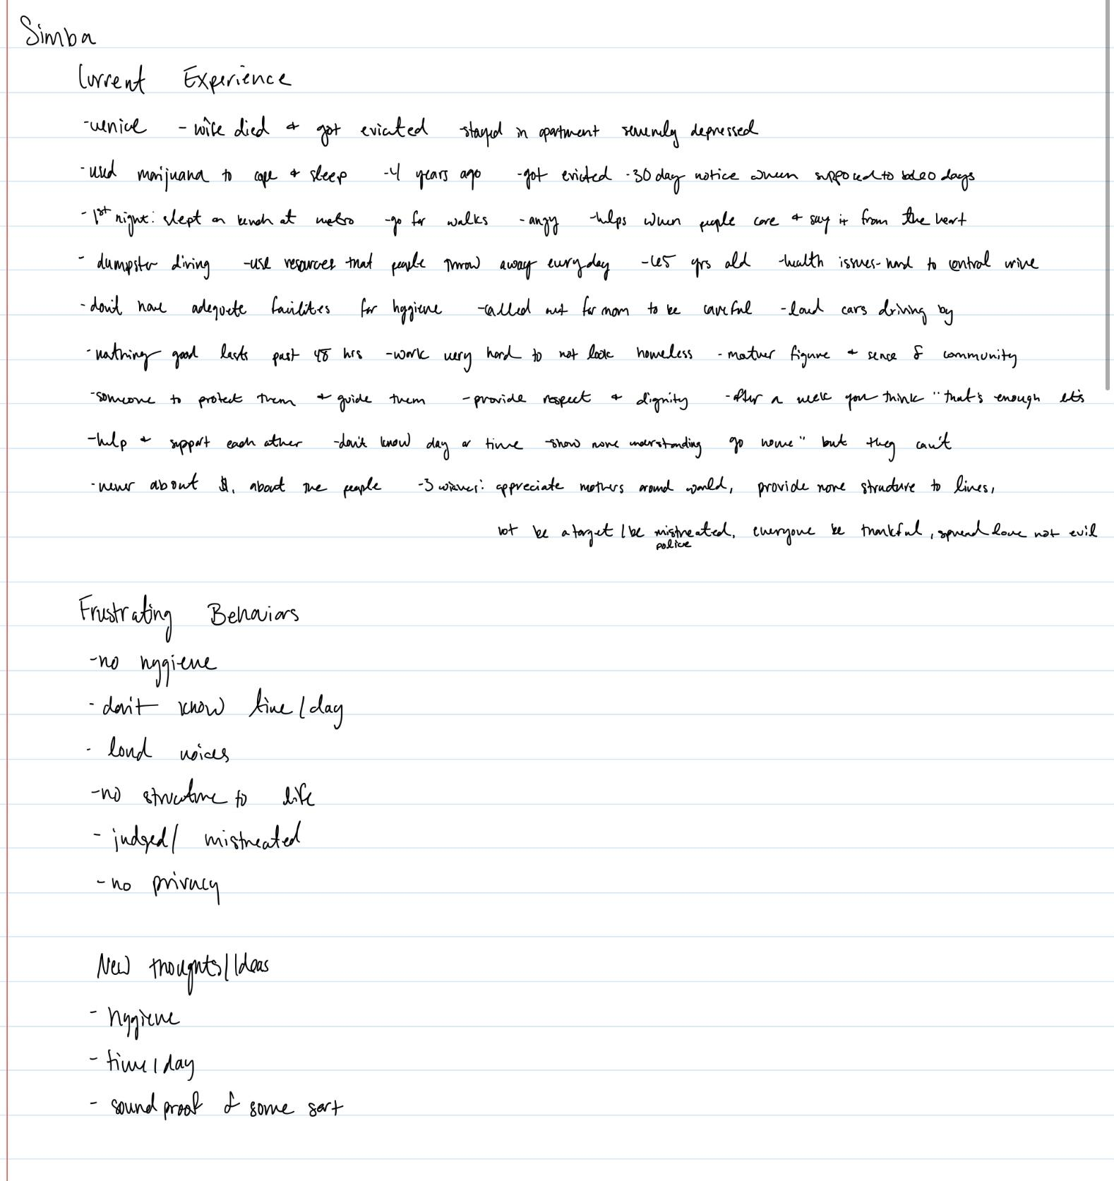

***Focus Group Interview Notes:***

1. **How often do you go camping? (Leah)**

**Vijay:** I love the outdoors and hiking camping-- been a long time Family camping going out as a family and being there eventually going out and backpacking, college days quite a bit of camping, wherever you spend your night and go out whenever and wherever you can.

**John:** Gone out into the wilderness with a backpack with tent and everything needed to survive in wilderness for 3 or 4 days, do this at least once a year, most recent experience was last summer, hiked a section of the appalachian trail for 34 mile hike with son, brought tent, backpack, food, water filtering supplies

1. **What do you find to be the most difficult part of camping? (Ashwin)**

**Vijay:** Most difficult when the weather is not accommodating, rest of the most is really fun and enjoying, the weather is definitely the most difficult part of it. Bugs at certain times of a year are more intense than other times, not always there. Shelters for the homeless out there are there the entire year so really think about the weather.

**John:** Weather can make it a lot more challenging and also it’s not just rain and wind that can be difficult, but the intense sunlight can sometimes be too much so you might need to look for a shady spot and somewhere to cool off, and bugs are also annoying. Try to avoid the buggy season, but sometimes you just have to go when you can go. Bug spray can get sticky and make you feel dirty. When you are camping you have to get used to not smelling so good and not being clean for a few days. Other challenges are sleeping, when you’re sleeping on the ground, you get loose heat through the ground/air, so it can be very cold on the ground. You need an insulating layer on the ground between you and the ground.

1. **Do you prefer to camp alone or with others? (Leah)**

**Vijay:** Like to camp with friends and like to be around other people and go along with other people with your friends with a really positive environment to share experiences with other people. Homeless people that's another challenge because they are alone, robbed, beaten up, and the mental balance of just being alone in that environment is really hard.

**John:** I like to have some companionship while I’m out camping, there’s always that inevitable experience that you can look back on years later and laugh at. So it’s definitely nice to have company.

I was thinking about that (homeless loneliness) today. There’s a constant security threat wherever they live, there are other homeless people on the streets looking for whatever they can get, they’re desperate.

1. **What type of weather do you typically camp in? (Ashwin)**

**Vijay:** Best time would be summer or fall, just because it's cold in the winter and not as fun because you are really confined since you can't really get out as much.

**John:** Summer or Fall. I prefer late summer-fall because there aren’t too many bugs and the sun isn’t too intense.

1. **If you camp during cold weather, how do you typically stay warm at night? (Leah)**

**Vijay:** Sleeping pad has insulation that does help a little bit, Put up a fire and keep yourself warm. Marathon race at the finish line they have space blankets, to help keep them warm after the race. Collapsable is very good, the lighter you get it gets more important→ Think about the budget and start adding up very quickly and get expensive. Rain protection comes in tents now as a standard item. Tent that I bought is 2half to 3 pounds and cost 600 dollars, the lighter the betters each pound goes on you as time goes.

**John:** Went camping in the late Fall, was really cold because I slept in a hammock. It was kind of windy, and the wind was blowing all around me as I was laying in the hammock so I was freezing, so to warm myself up, I wrapped myself up in my sleeping bag, I wore a hat and gloves and socks. I zipped my sleeping bag up so much so that there was just a little hole for me to breathe through.

Also if people are at risk of getting hypothermia, there are these “emergency blankets” “mylar” blankets/sleeping pads with a reflective surface to keep the heat in, this provides insulation as it reflects the heat back towards the body.

Something else I was thinking about with the people who are homeless: they have to take everything they own with them because if they leave anything behind it might get stolen. With backpacking, you’re always trying to manage the amount of weight with you. You are always trying to minimize your weight, but you have to carry certain things with you (water, food, tent) and usually your tent is the heaviest thing you take with you.

Can’t move around inside tiny little tents. You don’t want to bump into the sides because of the condensation, otherwise you’ll get wet.

Portability is important. Come up with a design with only a few parts. They don’t have access to tools to put together a lot of parts, or something might break or get lost. So create something with the least number of parts. (think like a play tent, rigid but flexible material, can collapse and twist into a circle that is super flat, put in a bag, and the bag holds it together).

Ideal tent weight: 2 person tent with aluminium poles and stakes with a rain canopy over top, 5lbs (moderately priced camping unit, pain about $99 for it) titanium poles and stakes would make it lighter and making it a one person tent (would have to probably double or quadruple the cost just for it being lighter)

If you can get it in the 3-4 lb range and make it affordable, that would be ideal.

[Amazon.com : Mylar Emergency Blanket](https://www.amazon.com/Mylar-Emergency-Blanket/s?k=Mylar+Emergency+Blanket)

**One thing to think about: Condensation**

1. **On average, how many things does each individual person carry with them when camping? How many packs do these items require? (Ashwin)**

**Vijay:** Number of pockets all depends on the backpacks, aside from backpacks you can also have stuffing bags, to put you used clothes and food and other things you need→ 20 pounds is usually how much someone carries→ 20 pounds might not be enough for homeless people and carrying all that weight is not reliable for a homeless people. The fixed amount of time is something that campers do but homeless people don't have that fixed amount of time they live outside on a daily basis. (20 pounds is not reliable for a homeless person)

**John:** I agree that having things separated in bags (I have lots of different types of bags like mesh and waterproof bags and even though I have a cover over my backpack because I want my clothes to stay dry) by the time you add on the food, shelter and camping stove, then you need something to cook with and eat with. You always have to minimize everything. But the homeless person doesn’t have that option, they are constantly out there. I’m only out in the woods for a certain amount of time. All these things I’m carrying adds up. I’m carrying 35-36 lbs and it's heavy! It hurts your shoulders and your hips. And as you go, you’re consuming your food and water so by the time you’re done, your weight might be closer to 30lbs. The homeless don’t know how long they will be out there. 20-30 lbs might not be feasible for them because they are out there for so long. I bring lots of little things though, lots of little containers for various things. If I am homeless I have to just use whatever I can find on the street or whatever people give me.

**They seem to always carry external backpacks or they have external storage areas→ We could integrate this as a pull out bag inside one of the pockets.**

1. **How would you describe your comfort level when sleeping in the shelter you currently use? What changes to that product would you make that would improve your camping experience? (Leah)**

**Vijay:** Don't have a lot of experience with camping outside! Last time that this happened was in college. Whistles are pretty handy in that they will scare the other person or animal away if a loud sound is present, and the sound deters the other person or animal.

**John:** Get nervous hearing noises outside my tent in the middle of the night. I know that there are bears and boars out in the mountains, so I’m deathly afraid that I’m going to get eaten by a bear or something like that (which this does happen). It’s a real threat that happens when you’re camping that bears could come in and mull you to death (yikes). I would make windows in my tent so I can look out my tent and see if there’s a bear.

A homeless person could be threatened by other people. You can scare a bear away, but with other people, if they really want something, they might just attack. So make a way that they aren’t going to get confined in their tent so if they need to get up and run away quickly, they will be able to do that.

**Windows: Great thing to look at for design (Also fixes the problem for homeless people in that they don't feel confined in their shetler if theres windows present)**

**Whistle: Great for security, the sound might deter another person (or animal in hiking)**

1. **Do you have any camping gear brands that you are loyal to? What do you like about those brands? (Ashwin)**

**Vijay:** Backpacks go to Osprey; Osprey is really good in the sense that it has a lot of storage and pockets that allows for storage in multiple areas which is great; Jet-boil: very convenient and boils water in about a minute. Don’t mess around boiling water and things like that which is good, and it's easy to do that.

**John:** I also like the Osprey, and I also like Kelty. Both are really good backpacks. I really like how there are lots of compartments that I can use to organize things. Some compartments are less accessible for when I'm walking and others are easily accessible.

Caddedine for water filters.

Jet-Boil for cooking pots, super lightweight and super efficient because they don’t burn your food.

1. **Do you typically prioritize quality or price when it comes to camping gear? (Leah)**

**Vijay:** Both, as the quality improves, the price definitely goes up. If given a choice, then you definitely want the best quality because that will give you the best service for what you want to do.

**John:** I agree the quality is really important because I want to be comfortable. Whatever is going to be the most comfortable is what I want!

1. **Have you noticed any recent trends in the camping industry? (Ashwin)**

**Vijay:** Tents the way they build them recently come across- is that it is a minimalist tent (Walking poles that hiker uses turns into the frame of the tent), less things to carry and and is very easy to use in the sense that hikers already use walking poles so using the walking poles to build the frame of the tent is very convenient. And also important element is shoes because the better the shoes in a hiking experience the more comfortable you are, lighter, insulators, socks is another great thing smart wool line the socks which keeps the heat in and keeps you warmer same material is also in shirts and also in pants and keeps you warm. “**SmartWool”.**  The fitting of your shoes if its not cu=orrectly fitting you, you can get a lot of

**John:** I love everything about the campaign supplies, so I look at all the different details and features of the products that are out there. For water bottles and water filtration systems, they’re improving the efficiency of cleaning the water to get the bacteria out of the water so extra chemicals and treatments aren’t necessary. So water filtration is very important when you’re backpacking.

Yeah, the shoes are definitely a big thing. Because your feet will hurt and get so sore especially when you are hiking for a long time on an uneven rocky surface. The socks are absolutely critical, You need socks that wick the moisture away from your body. I use **“polypropylene socks”**. You have to change your socks frequently otherwise you get wet feet and get blisters, So having socks that dry out quickly is important.

1. **How much would you be willing to pay for a product like this? (Leah)**

**Vijay:** Depends on the features you are going to provide, if you solve problems mainly the wight putting it up getting it, all these factors, factor into price→ the average price that the market would pay for right now would be about 100 to 200 dollars, I would suggest a trip to REI, one place to see everything through the camping industry, see things that are available.

**John:** I agree, I think the same things ($100-$200) and also I was thinking you could do a market analysis. See how many tents are being sold and for what cost to get an idea of how much things are being sold for. (For the 1 for 1 model) you need to make sure that you are making enough money for the one you sell to also pay for the one you are giving away. Make it affordable enough so that people will want to buy it and also make enough to give one away.

1. **Do any other products/services come to mind when you think of this product? (Ashwin)**

**Vijay:** Campout is the first preference, the people that you go out with, does not tend to go into the camping, they all lean towards the cabin, but would much rather go camping

**John:** I would agree, I prefer to be out in the woods and not in a cabin, but it depends on who you are going with.

1. **What is your day job and what character traits do you think one must have to perform this job well? (Leah)**

**Vijay:** Daily job is just the opposite of going camping→ on the IT side of the world→ Totally opposite of being in the camping world→ Looking forward to retiring so I can finally go out into the world→ Feeling of loneliness, losing that interaction and working face to face with people, just being around other people tend to create a connection with whoever is around you, it's not the same as the virtual setting, that connection is there, generally setting up a meeting for mainly work, as soon as the work element is done the call is done, but in the face to face environment you can really learn more about this person.

**John:** Same for me, I’m constantly in front of my screen all the time in front of my computer. I don’t get to go into the office (due to COVID) even though we have the screens and get to interact with people, it’s not the same as being with people. My preference though would be to be out in nature and get the sensory stimulation I get from being outdoors.

Loneliness: I think that loneliness is the description of the feeling, it feels isolating, not having somebody to talk to or interact with or just see because sometimes just seeing or overhearing what people are up to without having to call them is nice, so it’s very isolating and it makes the interactions more difficult because you don’t know if the person you want to interact with is busy, whereas if you are in person you can be a little more spontaneous with your colleagues. But when you’re isolated and can’t have that throughout the day, then the feelings of loneliness and isolation sets in.

Another thing I was thinking about while you were talking so that I feel more mentaly fatigued when I’m working alone. I don’t know if it's because I’m looking at the screen all the time or if it’s because I can’t talk with people for a moment, but it makes me feel fatigued.

**Peer to peer center has to be in person because it create that connection and it reduces that mental fatigue**

1. **How do you incorporate camping into your life? Do you see camping as an individual activity or a family-oriented activity? (Ashwin)**

**Vijay:** Wish it could be family based, look out for friends who are like minded! Just the love of hiking, needs you to be in a good fit condition because that is what you need for hiking and forces me to be in a good condition, because it forces you to be in a condition to be good for a hiking/ camping trip.

**John:** I agree, I think I would like it to be a family activity, but not everyone always wants to go with me.

I watched lots of youtube videos about camping before going the first time, read books, and really did a lot of research. I incorporated characteristics of a good camper into my daily life by being prepared. For example, I got a little first aid kit that I carry with me all the time. Sometimes I add new things due to situations I encounter that I previously wouldn’t have kept with me had I not had that experience.

I was motivated to start exercising so my body could be in a good condition to go backpacking.

1. **If you knew that buying a certain camping product would contribute to providing shelter for the homeless, would you be more inclined to purchase that product? (Leah)**

**Vijay:** Same thing goes for me, people who are looking out for a tent, could be an additional element to justify. Additional benefit for helping someone else justifies itself.

**John:** If it had the right features and it was the right price, then yes. I think that it’s a good cause and to know that there is another benefit to my purchase, it makes me feel better about wanting to do that.

Something else I was thinking about is if you could somehow incorporate materials that would be bound for a landfill/safe for the ocean. If you can incorporate materials that will be healthy for the environment, then you will have a really winning product.

**GREAT IDEA: Incorporate the idea of recycled materials because it helps the environment and campers want to protect the environment, alternative to plastic recycled.**

1. **What would be the max price that you would be willing to pay for a shelter if you know that a majority of the money is going towards a good cause. (Ashwin)**

**Vijay:** Price wise competitor enough so it can stand with the competitors so it can be 10-15-20 percent higher than the original competitors on the market, if the other product gives me the same features for a higher price can't justify the idea paying that price because the competitors is at a lower price for the same features cant be justified, additional features inside the tents as well, in built LED light→ Add on as an accessory

REI Online Store: [Backpacking Tents: Best Small and Lightweight Tents for Adventuring | REI Co-op](https://www.rei.com/c/backpacking-tents)

**John:** I was also thinking that. It should be comparable to other products from a pricing standpoint. People will be willing to pay a little more for the added benefits like having materials that are healthy for the environment and knowing that their purchase will help someone else. Double the price is too much more.

Another factor we haven’t talked about is the design. Expensive tents have a more refined style. If you can incorporate well thought out design elements, then you can demand a higher price for it because it is designed so much better than other products.

1. **Do you have any memorable experiences with the homeless population or serving in homeless shelters? (Leah)**

**Vijay:** Personally I don't, seen a lot of homeless people→ have a talked to one or two, have not gotten a chance to get close to anyone yet

**John:** For me, my experience is when we went out with church one time for “hiking in the city” we would bring along with us some socks, snacks, and other different things that they would need. Yeah, I think that my experience is that there is a certain sense of desperation with them. They knew when we would come, and they recognized us. They always knew that we were going to show up. If we were handing things out, they would take whatever they could get. They really loved to get those fresh socks. The other thing is that I think they wanted to talk with people, or maybe they were feeling maybe even more lonely or isolated than I feel today. Just hearing about their story helps you to feel a little bit more compassionate towards them. They need things just to survive the next 24 hours. They are thinking about what am I going to eat tonight? Where am I going to sleep tonight? Their needs are immediate.

Hiking in the city = **GREAT MARKETING TOOl**! This can be incorporated into the current plan as well. **Fits with the brand as well**